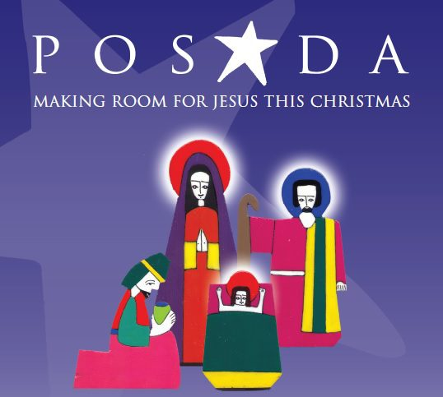

*EFL BENEFICE POSADA 2024*

Will Mary and Joseph visit your home this Advent?

The parish posada, of Mary, Joseph and the donkey, will travel across our parish for the first time this Advent and parishioners are invited to act as “host” by taking it home for a night to share the Christmas story with family and friends, before passing it on to the next host. The Posada will be blessed in St Peter’s and St Paul’s on the first Sunday of Advent (1 December) and parishioners wishing to host the Posada can do so using the Journey Rota. {See Trudi}

The Posada will spend the first week of Advent at Anthony Roper then journey across each of our parishes. It will return to church every Sunday.

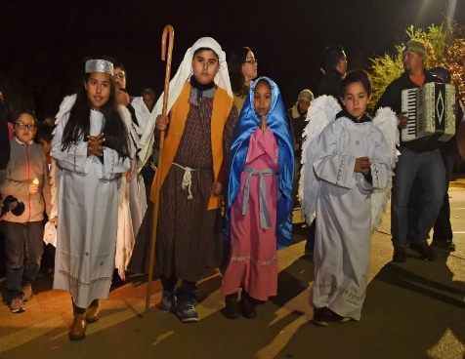**What is Posada?** Posada is an old Mexican tradition where young people, dressed as Mary and Joseph, travel from house to house asking for a room for the night and tell the story about the imminent arrival of Jesus, during the weeks leading up to Christmas. On Christmas Eve, they visit the local church and re-enact the nativity and place figures of Mary and Joseph in the crib.

The modern day Posada uses nativity figures of Mary and Joseph and the donkey who travel from place to place within the parish. This gives individual parishioners (or schools, nursing homes etc) the chance to ‘host’ the posada and to create their own celebration of the real message of Christmas, making room for Jesus in their lives.

**How can I host the Posada in my home for a night?** All you need to do is add your name and contact details to the journey rota (ask Trudi) on a date that suits you. The person who is hosting the Posada on the day before you will deliver the posada to you at an agreed time. You are then expected to make arrangements for the posada to be delivered to the next host on the following day. If you are unable to get to church to complete the Journey Rota or have difficulty with delivering the Posada to the next host, contact Trudi 07432131079 who will be happy to help you.

For the evening that you host the posada, you might like to invite family and/or friends to join you in your celebration or you might prefer a quiet evening of prayer and reflection – it’s up to you. We provide a sheet with suggested prayers but you can adapt or add to these as you wish. We also invite you to share a picture and/or a short account of your experience of hosting the posada in your home, for inclusion in the parish website, and Facebook [if children are not allowed on media please just take a photo without them in it]

We have produced a separate sheet Hosting the Posada – A Few Practical Tips along with a sheet of Suggested Prayers & Reflections. A copy of each is included in the Posada pack.

Finally, hosting the Posada can be an opportunity to share our faith with family and/or friends but, above all, it’s a chance to celebrate Advent and think about our journey towards Christmas.

It’s as simple as that!